**题目：**

实现一个ArcGIS Experience Builder widget

**要求：**

1. 功能要求：
   1. 这个widget的主要功能是展示一个数据的汇总信息，细节见design.pdf
2. 开发者文档要求：
   1. 列出开发这个widget所使用的SDK的主要的功能
   2. 在目前开发者文档里面，上述功能在文档方面是否有问题？如果有，请列出
   3. 针对上面有问题的文档，选出3-5个做修改
3. 用户文档要求：
   1. 列出目前用户文档的问题
   2. 给这个widget写一个简单的用户文档
4. 面试的时候需要讲解：
   1. 上面作业的要求
   2. 你对本产品功能和技术方面的理解

**参考资源：**

<https://developers.arcgis.com/experience-builder/>

<https://www.esri.com/en-us/arcgis/products/arcgis-experience-builder/resources>

## 1. Info Summary widget development

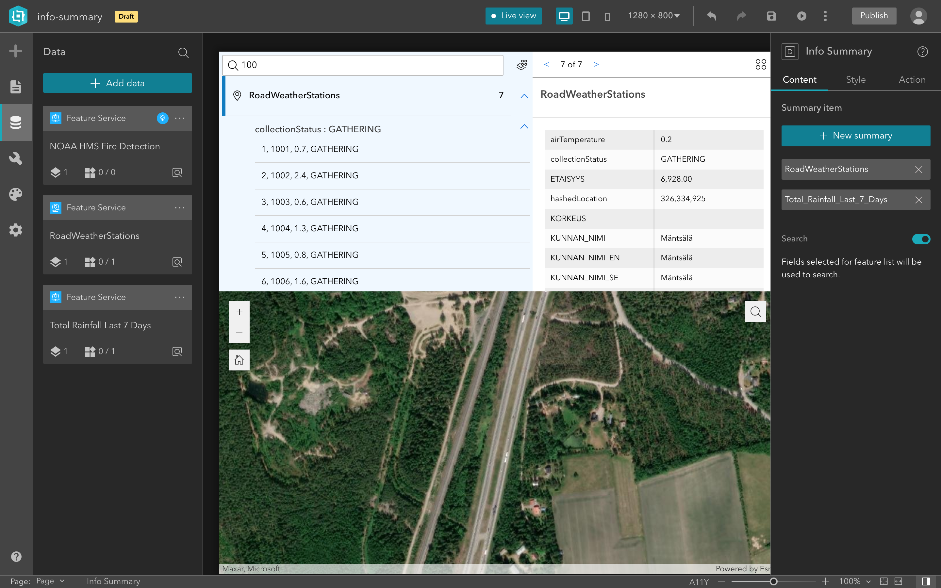

Pic 1 Setting panel & Runtime

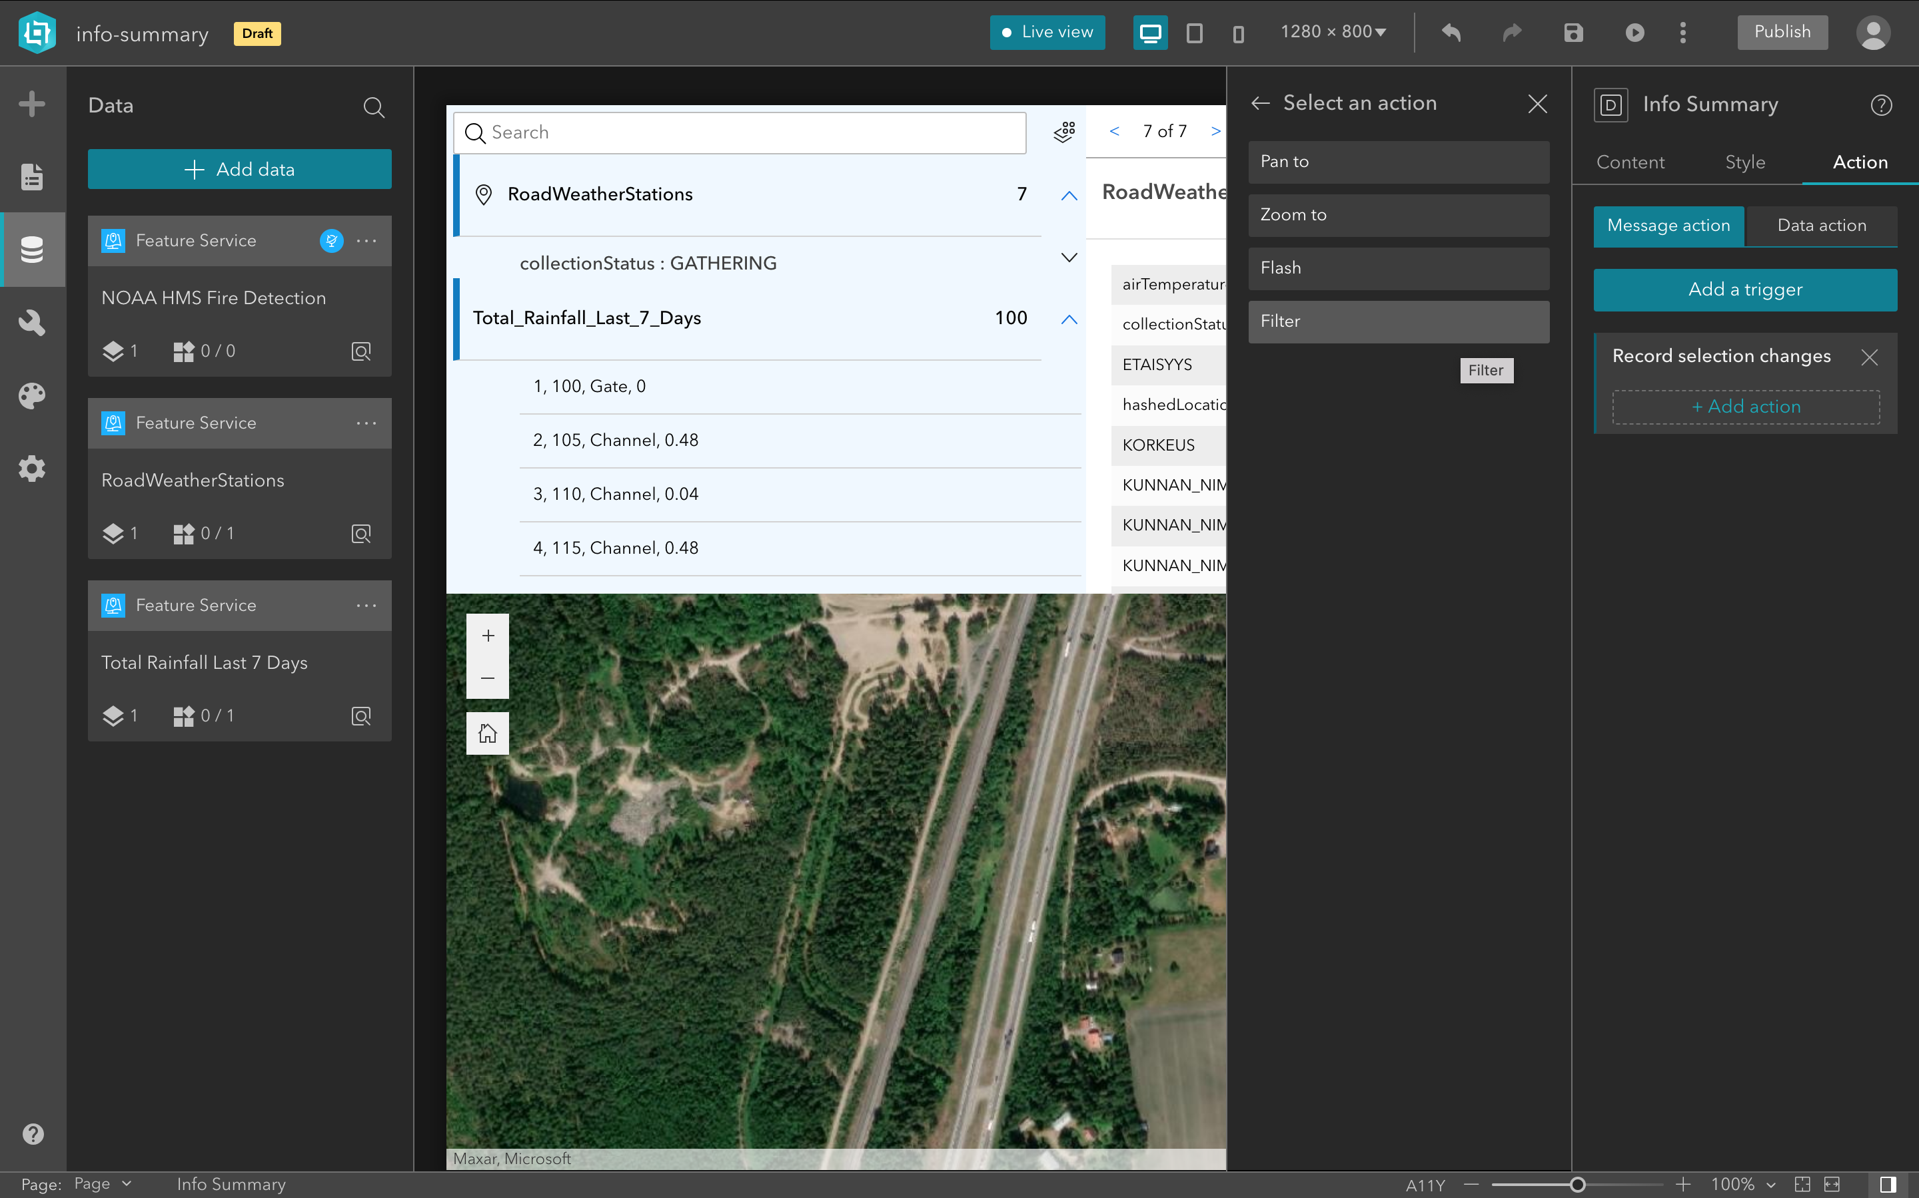

Pic 2 Action panel & Runtime

## 2. Document for developers

### a. Most used SDKs

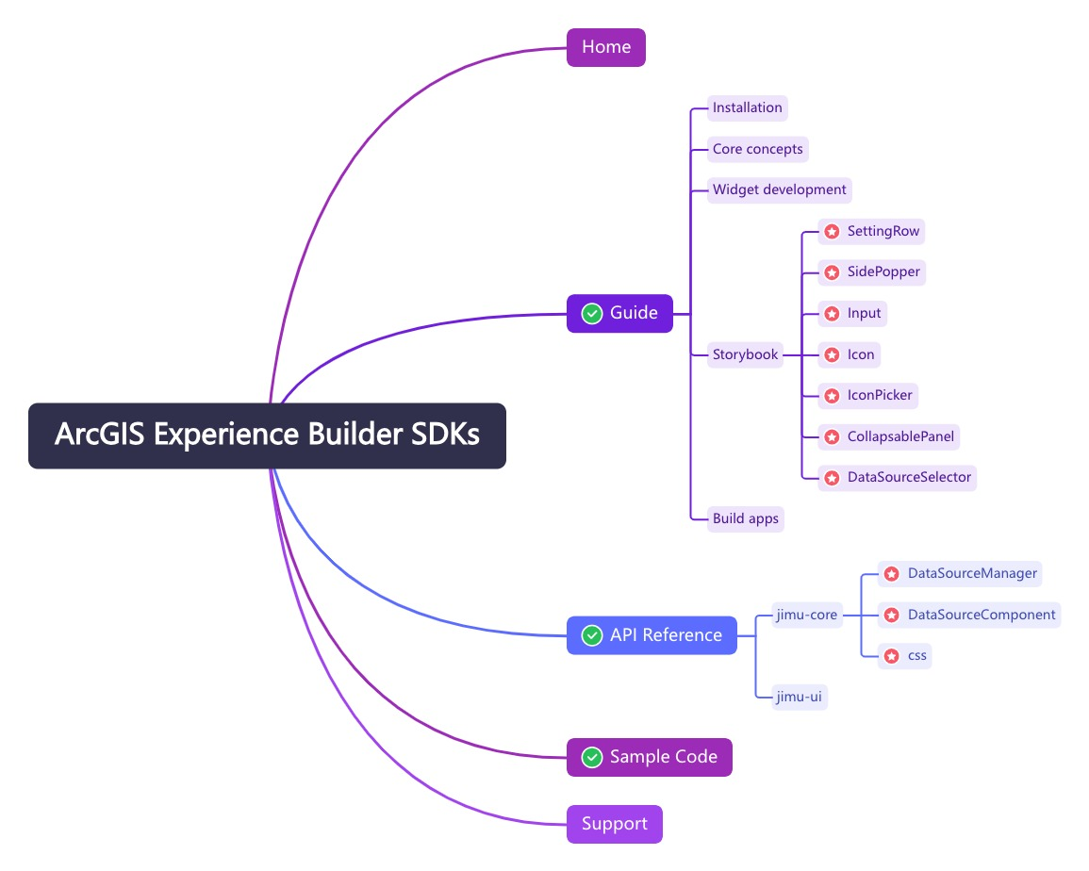

Pic 3 key features used

Tab 1 Most used SDK parts table

|  |  |  |  |
| --- | --- | --- | --- |
| **NO** | **Type** | **Chapter** | **SDK Name** |
| 1 | Home | * | / |
| 2 | Guide | Installation,Core concepts,Widget development,Storybook,Build apps | SettingRow,SidePopper,Input,Icon,IconPicker,CollapsablePanel,DataSourceSelector. |
| 3 | API Reference | jimu-core,jimu-arcgis | DataSourceManager,DataSourceComponent,css. |
| 4 | Sample Code | / | / |

### b. SDK issues

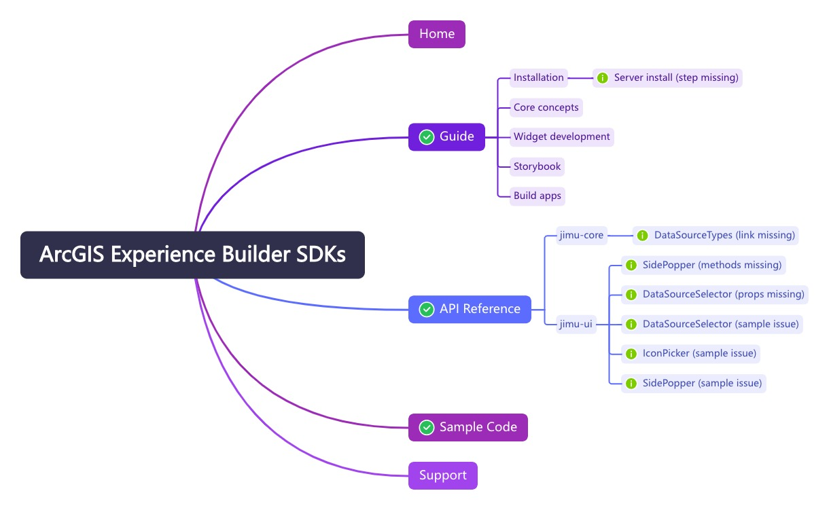

Pic 4 SDK Issues

Tab 2 SDK Issues table

|  |  |  |  |  |  |
| --- | --- | --- | --- | --- | --- |
| **NO** | **Type** | **Chapter** | **Part** | **Issue brief** | **Issue description** |
| 1 | Guide | Installation | [Server Install](https://developers.arcgis.com/experience-builder/guide/install-guide/#server-install) | Server installation key step missing | In the step description of installing the server-side program, step 7 lacks necessary instructions for configuring the app URL. |
| 2 | API Reference | jimu-arcgis | [DataSourceTypes](https://developers.arcgis.com/experience-builder/api-reference/jimu-arcgis/DataSourceTypes/) | Link missing | Missing jump hyperlink to DataSourceTypes part of jimu-core. |
| 3 | API Reference | jimu-ui | [*](https://developers.arcgis.com/experience-builder/storybook/?path=/docs/welcome--docs) | Lack related EXB version | Different version of EXB may have functionality difference in jimu-ui. |
| 4 | API Reference | jimu-ui | [SidePopper](https://developers.arcgis.com/experience-builder/storybook/?path=/docs/components-jimu-ui-advanced-setting-components-sidepopper--docs) | Sample code issue | The sample code lacks the required attributes ‘isOpen’ and ‘trigger’. |
| 5 | API Reference | jimu-ui | [SidePopper](https://developers.arcgis.com/experience-builder/storybook/?path=/docs/components-jimu-ui-advanced-setting-components-sidepopper--docs) | Sample style issuce | The outer container of the sample is too small to see the whole sample. |
| 6 | API Reference | jimu-ui | [DataSourceSelector](https://developers.arcgis.com/experience-builder/storybook/?path=/docs/components-jimu-ui-advanced-data-source-selector-datasourceselector--docs) | Sample code issue | The sample code lacks the required attribute ‘types’. |
| 7 | API Reference | jimu-ui | [DataSourceSelector](https://developers.arcgis.com/experience-builder/storybook/?path=/docs/components-jimu-ui-advanced-data-source-selector-datasourceselector--docs) | Props missing | The props table lacks the attribute ‘className’,’ sidePopperTrigger’ etc. |
| 8 | API Reference | jimu-ui | [IconPicker](https://developers.arcgis.com/experience-builder/storybook/?path=/docs/components-jimu-ui-advanced-resource-selector-iconpicker--docs) | Sample code issue | The sample code uses the <Controlled> tag instead of the <IconPicker>. |

### c. SDK issues modification

Tab 3 SDK Issues modification table

|  |  |  |  |
| --- | --- | --- | --- |
| **Issue NO** | **Part** | **Issue description** | **Modification** |
| 3 | [SidePopper](https://developers.arcgis.com/experience-builder/storybook/?path=/docs/components-jimu-ui-advanced-setting-components-sidepopper--docs) | The sample code lacks the required attributes ‘isOpen’ and ‘trigger’. | <SidePopper  position="right"  toggle={() => {}}  isOpen={isSidePopperOpen}  trigger={btnRef}  /> |
| 5 | [DataSourceSelector](https://developers.arcgis.com/experience-builder/storybook/?path=/docs/components-jimu-ui-advanced-data-source-selector-datasourceselector--docs) | The sample code lacks the required attribute ‘types’. | <DataSourceSelector {...otherArgs}  types={DataSourceTypes.FeatureLayer}  useDataSources={useDss} onChange={onSelectedDsChange} hideAddDataButton={true} /> |
| 7 | [IconPicker](https://developers.arcgis.com/experience-builder/storybook/?path=/docs/components-jimu-ui-advanced-resource-selector-iconpicker--docs) | The sample code uses the <Controlled> tag instead of the <IconPicker>. | <IconPicker  className="flex-none"  configurableOption="color"  hideRemove  previewOptions={{  autoFlip: true,  color: true  }}  /> |

## 3. Document for users

### a. Tutorials issues

Tab 4 Tutorials Issues table

|  |  |  |  |  |  |
| --- | --- | --- | --- | --- | --- |
| **NO** | **Type** | **Chapter** | **Part** | **Issue brief** | **Issue description** |
| 1 | * | * | [*](https://doc.arcgis.com/en/experience-builder/latest/get-started/what-is-arcgis-experience-builder.htm) | Search UE not friendly | The search box at the top of the page is not easy to use. Adding a search box to the left menu may be a better choice. |
| 2 | Home | / | [Search](https://www.esri.com/en-us/arcgis/products/arcgis-experience-builder/resources) | Search result confusing | The search result is confusing which display related information of all version of EXB. |
| 3 | Tutorial | Try ArcGIS Experience Builder | [Create a web experience from a template](https://www.esri.com/arcgis-blog/products/experience-builder/mapping/get-started-experience-builder-foldable/) | Layout mistake | The layout of the article page is different from others written by the writer, which looks unusual. |
| 4 | Tutorial | Try ArcGIS Experience Builder | [Get started with ArcGIS Experience Builder](https://learn.arcgis.com/en/projects/get-started-with-arcgis-experience-builder/) | Test version missing | Tutorial is different from article while tutorial is more official. Different EXB version may have functionality difference. |

### b. Info Summary Widget

The Info Summary widget provides the ability to retrieve, count, and display information from multiple lists. List items support custom icons, text, statistics, and other information. You can combine the widget with the Map widget to interact with the map by clicking on items, which help to develop richer applications.

**Example**

Use this widget to support app design requirements such as the following:

You want to aggregate information from multiple lists and customize the list titles and icons.

You want to display list item information and group by specific field values.

You want to search for all list items in one place, with configurable search fields, and interact with the map after clicking on the search results.

**Usage notes**

When you add a Info Summary widget, first click button and choose the data source，setting the **Label**, **Icon**, **Feature** **list** and other information of the data source. At this time, a **Summary** will appear in the Runtime and a long **button** with the data source information in the **Content panel**. Click the button to modify the settings or delete the Summary. Finally, if you check the Search option, a search box will appear in the Runtime, which supports searching the configured fields.

Each Summary element has two states - expanded and collapsed. When expanded, it shows the item which contain custom icon and text composed of configured fields. When collapsed, it shows the Summary icon, label and the total number of items.

**Settings**

The Info Summary widget includes the following settings:

**New summary**- Add a Summary record to the Content panel and open the Data SidePopper to select the data source bound to the Summary record.

**Select data**- Select feature layers as a data source.

**Label**-Set Label of the Summary record，the label support user-defined input, and the default value is the label of the data source.

**Count**- Set whether to count the number of items in the Summary. If checked, the number of items will be dynamically displayed in the Summary item Runtime.

**Feature list**- Set whether to display the content of Summary items. If checked, you can set display fields, grouping fields.

**Search**- Set whether the widget supports search. If checked, the search box will be displayed in the Widget Runtime.

**Interaction options**

You can use Info Summary Widget to control feature layer display in best map view 。

To do this, click Add a trigger on the Action tab of the Button widget's settings. Select the Button click trigger, then select a target widget and action. Currently, you can connect a Button widget to the following other widgets:

Tab 5 Trigger & Action

|  |  |
| --- | --- |
| Target | Action |
| Map | Record selection changes-Zoom to specific position of the record in Map |